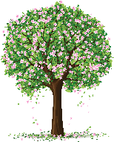
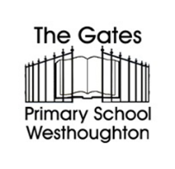
Summer 1
KS1 Curriculum Newsletter

Dear Parents/Carers,
Welcome back after the half term, we hope that you all had a restful break. We are now into our first half of the Summer term and have lots more exciting learning planned for your child. This is the work that the children will be covering over the following term in KS1:

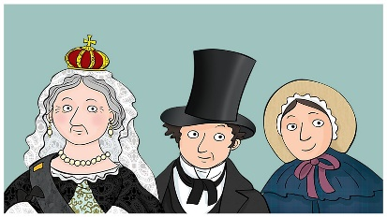  History:  This term, we are studying the Victorian era. We will explore how people lived, worked, and dressed during this time. We'll learn about Queen Victoria and understand the differences between the lives of the rich and the poor. |  | DT  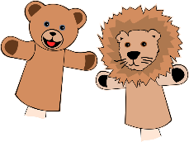  In DT, we will be looking at our new topic of textiles linked to ‘Enterprise Day’. We will evaluate existing products, practise stitching, and explore different ways to join materials to develop the skills to design and make a puppet. These will be marketed and sold during Enterprise Day.
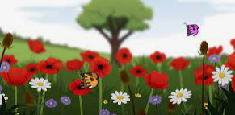
Science:
In Science, we are studying plants. We will learn about different types of plants and their parts, including wild and garden flowers, as well as evergreen and deciduous trees.
PE:  This half term our indoor PE lessons will focus on ‘competitive sport’ and our outdoor PE lessons will focus on ‘Basketball’, practising skills and technique for game –based play.  PE days:  Robins: Monday & Tuesday  Owls: Monday & Thursday  Woodpeckers: Wednesday and Friday |   RE:  In RE this half term, our enquiry question is ‘Who created the world?’ We will be focussing our learning on Christianity. We will be learning about Creation and how it fits into the Christian ‘Big Story’ and the relationship Christians have with God as their creator. | 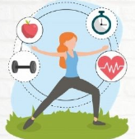  PSHE:  Our topic for PSHE this half term is ‘Health and Well-being’. We will learn about physical and mental wellbeing and keeping safe. We will look at the importance of sleep, routines and sleeping habits that keep us healthy.
  Computing:  We will be completing our Information Technology unit this half term. In this unit we will learn about what the internet is, how to use search engines, how to conduct safe searches and ways to help us distinguish between real facts and fake news. |  |   Music:  Linking to our Victorians topic, we will be listening to a variety of music created during the Victorian era. This half term allows us opportunities to perform songs as part of a group. We will be learning some Victorian songs such as ‘Daisy Bell’ and ‘I do like to be beside the seaside’
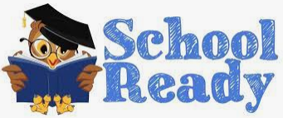  Please ensure your child is always fully prepared for the school day with their school bag, reading record & reading book, homework, and anything else they may have been asked to bring in. |  |   Home Learning:  - Read at home for 15-20 minutes every day  - Practice spellings  - Learn times tables  - Create one example from the half termly project list
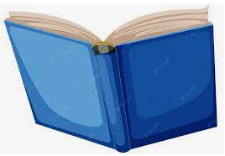  Home Reading: Please ensure that your child reads 5 times a week  Reading Challenge  5 x= Green  2/3/4= Yellow  0/1= Red  If your child achieves green for the week, they will be entered into a special prize draw and have the chance to win a book from our vending machine!  Only books that children take home from school will go towards the reading challenge – either the home reader or a book from the 100 Book Challenge. This will ensure that your child is reading books appropriate for their ability. |  |   Twitter Pages  Each class has a Twitter page which is updated regulary. You can see all the exciting things we have been getting up to in school and how hard the children are working. Please follow us to keep updated!  Robins: @GatesRobins  Owls: @Gates_Owls  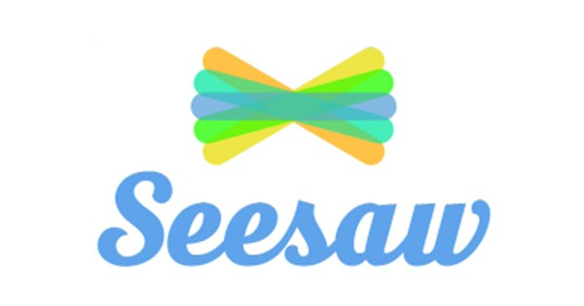  Seesaw is an app we use to track your child’s learning and progress throughout the year. We will send out additional information on how you can view your children’s work as well as how to use this app to share WOW moments from home with us in school.

