

**Option 4: Practise your basketball skills.**

Practise using both hands to bounce a basketball. Upload pictures or a video to Seesaw.



**Option 2: Draw, paint or create a Victorian building**

What was it like in a Victorian home? What was it like to work in a Victorian cotton mill?

The Victorians were known for their grand homes and large mills. Draw, paint or create a model of a Victorian building.

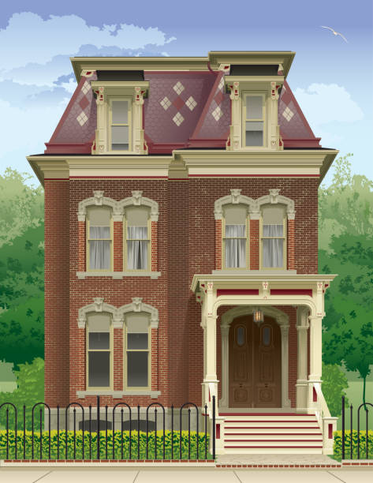

**Option 1: Create a fact file about a famous Victorian**

Make a fact file about a famous Victorian such as Charles Dickens or Queen Victoria.

You could create this using Purple Mash or .using paper and pencils/pens.

There are additional activities on Purple Mash that focus on the Victorians too.

**Option 3: To follow a recipe from a Victorian menu**

Measure out the ingredients for a Victorian recipe. Follow the recipe to create a delicious treat. Take photos and share them on Seesaw.

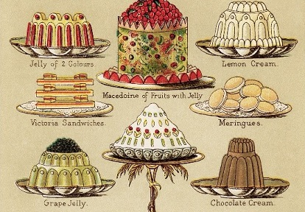

**KS1 - Homework Web**

**Summer 1 – The Victorians**

Please choose 1 of the following projects to complete to help further your knowledge and understanding of this half term’s History topic. **Alternatively, if you have a burning desire to complete a different related project, you can surprise your teacher with that instead.**

