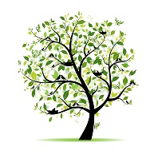

Summer 1
LKS2 LKS2 Curriculum Newsletter
Dear Parents,
We hope you enjoyed a lovely break over Easter and hope the children are feeling refreshed and ready for what promises to be a busy, but exciting half term ahead. Please find below information about the learning that the children will complete this half-term.

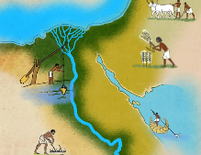  History:  In History this term, we are going to be learning about the Ancient Egyptians. We will begin the unit by learning about the earliest civilizations (Ancient Sumer; The Indus Valley; The Shang Dynasty), who they were and what they did. Following on from this, we will explore choronology to help us identify when the Egyptians lived, comparing them to other ancient civilisations. |  | 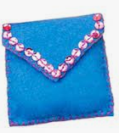  DT:  Within our DT textiles learning this term and leading  up to our Enterprise week, we will be combining our  History learning and that of the Ancient Egyptians to  create an Egyptian themed purse. We will focus on  the skills of stitching and threading to create unique  and original designs for our purse that will hold loose change and will close with a fixing. We will design, make and evaluate our product, as well as market the item to sell during our ‘Enterprise Day’.
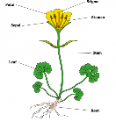
Science:
In Science this half-term, we will study a new topic of ‘Plants and their features’. We will explore the key parts of a
plant, what makes plants grow, transpiration and how to keep plants healthy through soil investigation. We will explore what is harmful to plants, the key components needed for plant life and what role seed dispersal plays in reproduction
PE: Orienteering-developing competiveness, communication & collaboration. Basketball- applying the knowledge developed over the year, including: SAQ, attacking & defending, send & receive & tactics & strategies.  PE days:  Woodpeckers: Wednesday and Friday  Swallows: Thursdays and Fridays  Starlings: Tuesday and Thursday |   RE: Christianity  Our key question this half term is ‘What kind of world did Jesus want?’ We will be learning about the biblical story of Jesus calling his first disciples and how Jesus’ actions might influence the life of a Christian. In addition to this, we will be learning about local Christian events and how these help to create the world Jesus wanted. |  | PSHE:  The children will discuss health and wellbeing in order to gain a greater understanding of how to lead a good life. They will learn how to maintain a healthy lifestyle through a healthy diet, regular exercise and by ensuring they practice good habits.
  Computing:  Within our Computing learning this term,  we will study Information Technology and in  particular, how the Internet works. We will  study how to recognise safe internet sites, password safety and how to spot scam web pages, including adverts. Our topic will culminate with a newspaper article for our DT Egyptian purses that can be added to our Twitter pages! |  | Music:    The children will explore body percussion. They will develop their sense of rhythm and use body percussion, to compose a piece of music in the style of a canon – similar to Frere Jacques. The canons, Pease Pudding and London’s Burning will be sung as songs and in canon form.
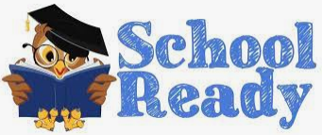  Please ensure your child is always fully prepared for the school day with their school bag, reading record & reading book, homework, and anything else they may have been asked to bring in.  Please can all children bring in an old shirt or t shirt (the bigger the better) that they can wear to protect their uniform during messy activities and Art. |  |   Home Learning:  - Read at home for 15-20 minutes every day  - Practise spellings & x tables  - Complete one example from the half termly project list  - Tasks set in homework books  Reading Challenge  5 x= Green; 2/3/4= Yellow; 0/1= Red
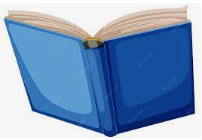  Home Reading: Please ensure that your child reads 5 times a week  Reading Challenge  5 x= Green  2/3/4= Yellow  0/1= Red  If your child achieves green for the week, they will be entered into a special prize draw!  Only books that children take home from school will go towards the reading challenge – either the home reader or a book from the 100 Book Challenge. This will ensure that your child is reading books appropriate for their ability. |  |   Twitter Pages  Each class has a Twitter page which is updated regulary. You can see all the exciting things we have been getting up to in school and how hard the children are working. Please follow us to keep updated!  @GatesWoodpecker  @GatesStarlings  @GatesSwallows  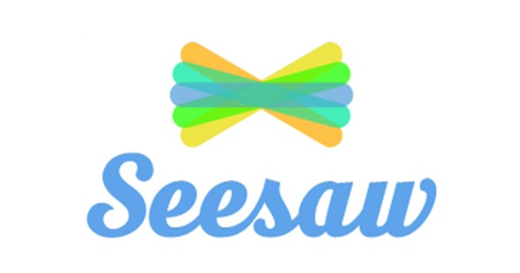  Seesaw is an app we use to track your child’s learning and progress throughout the year. We will send out additional information on how you can view your children’s work as well as how to use this app to share WOW moments from home with us in school.

