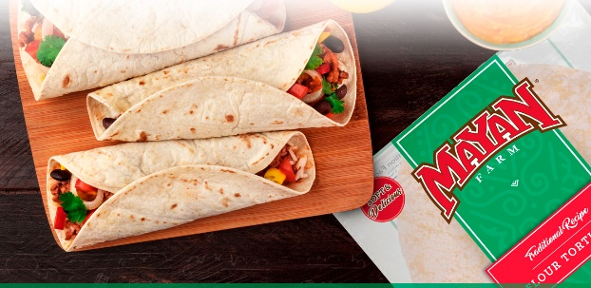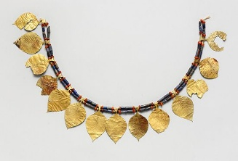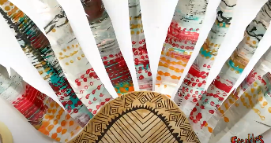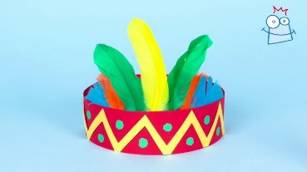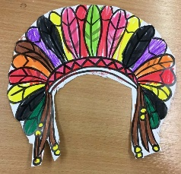

**Option 1:**

**History – Ancient Maya**

Design a Mayan Tortilla Recipe:

Invent your own tortilla fillings, reflecting on Mayan dietary habit. You could create a menu, a labelled drawing or even make it!

*The Maya ate a variety of foods with tortillas, including beans, meat, squash, chili peppers, and other ingredients. They would wrap these fillings in tortillas or use them as a base for dishes like tamales.*

**Option 2:**

**History – Ancient Maya**

Design Mayan Jewellery or a headdress:

You could use cardboard, foil, and gems to create traditional Mayan accessories.

**Option 3:**

**PE – Athletics**

Research an Olympic Athlete. Present your findings as a biography or fact file.

**Create a mini workout or practice session based on your chosen athlete’s sport or training routine.**



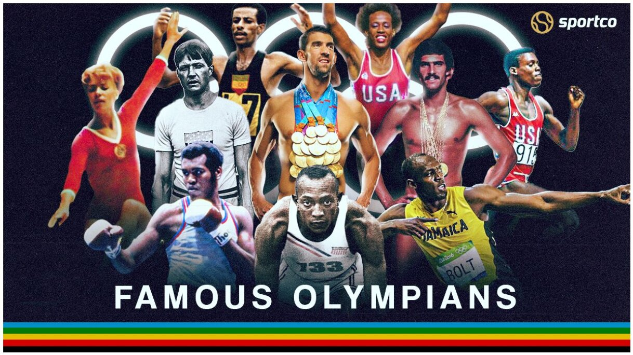

**UKS2- Homework Web**

**Summer 2**

Please choose 1 of the following projects to complete to help further your knowledge and understanding around one of this half term’s areas of learning.

**Alternatively, if you would like to complete a different project, related to another aspect of your learning, you can surprise your teacher with that instead.**