

**Option 2: Design a poster advertising a famous landmark in Australia.**

Include information about the landmark.



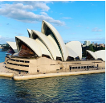

**Option 3: Create a fact file about an Australian animal.**

Research an animal native to Australia and create a fact file about it. You can present this any way you wish (Written/Seesaw/Typed), be as creative as you like!

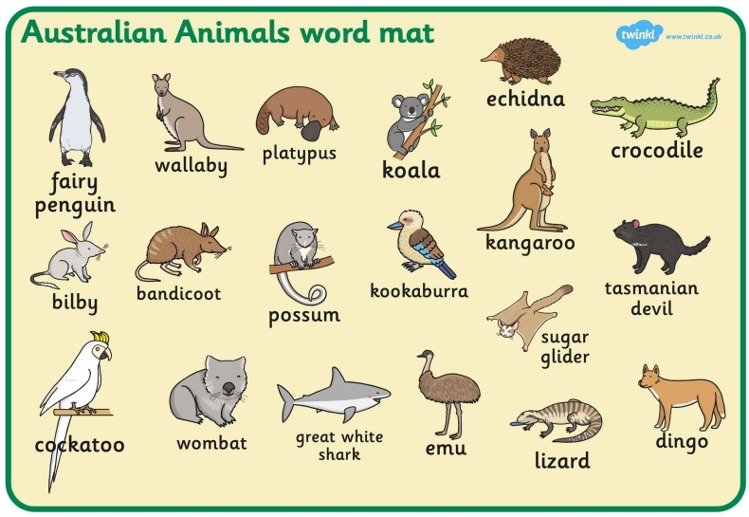

**KS1 - Homework Web**

**Spring 1 – Australia**

Please choose 1 of the following projects to complete to help further your knowledge and understanding of this half term’s Australia topic. **Alternatively, if you would like to complete a different related project, you can surprise your teacher with that instead.**

**Option 1:** **Make your own didgeridoo**

One of the skills we are learning in art is using different tools to create dot art. Could you used one of these skills to decorate your didgeridoo.

