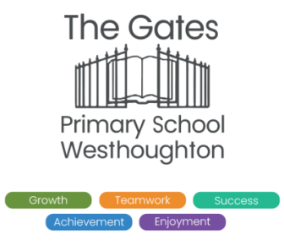

**Option 4:**

In Westhoughton, everyone is welcome and we celebrate the diversity of our town. Can you create a flag/poster/poem to welcome everyone? How will you make it clear that everyone is welcome here?

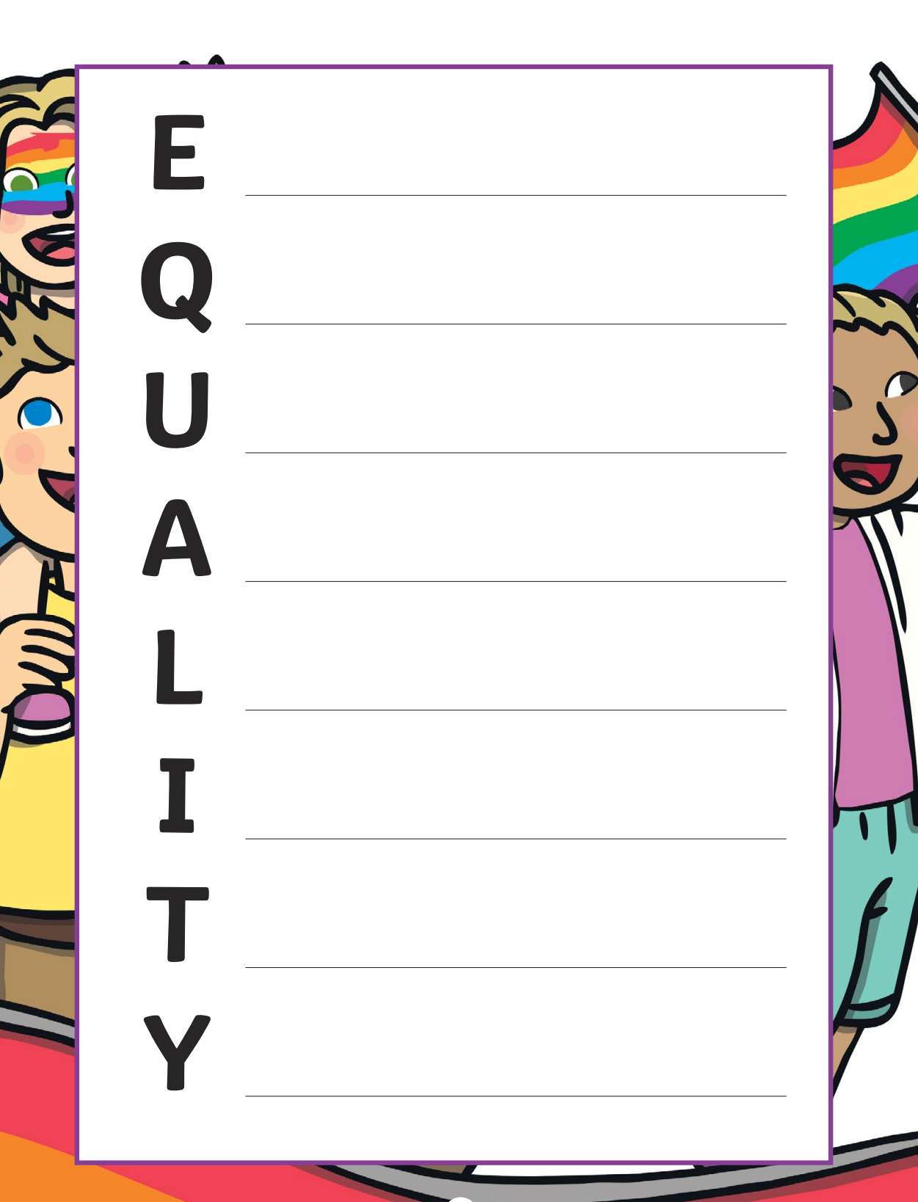

**Option 2:** Make a bug home.

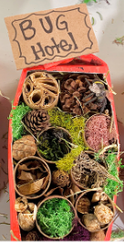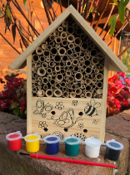

**Option 3:** Create an Earth craft. You may want to include different ways about how we can look after our planet.

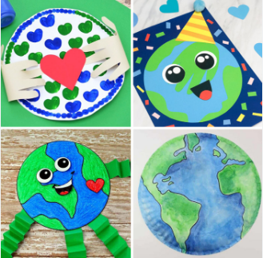

**KS1 - Homework Web**

**Spring 2 – Caring for the planet and sustainability**

Please choose 1 of the following projects to complete to help further your knowledge and understanding of this half term’s topic. **Alternatively, if you would like to complete a different related project, you can surprise your teacher with that instead.**

**Option 1:** Create a reduce, reuse and recycle poster.

It is important that we all do our bit to care for our Earth. Can you create a posted to encourage other to do the same?

