

**Option 3: Rainforest tribes wear many different types of traditional jewellery.**

Design and make your own tribal necklace. You can use any resources you wish, but may want to recycle items such as bottle tops or find natural resources such as feathers and stones.

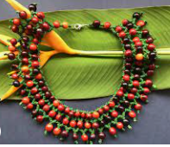 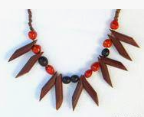 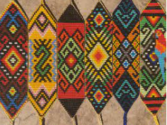 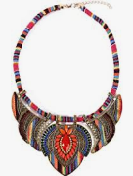

**LKS2 - Homework Web**

**Spring 1 - Rainforests**

Please choose 1 of the following projects to complete to help further your knowledge and understanding of this half term’s Rainforest topic. **Alternatively, if you have a burning desire to complete a different related project, you can surprise your teacher with that instead.**

**Option 1:** **Create your very own layers of the rainforest diorama**

Think about the best way to demonstrate your knowledge of the different layers of the rainforest and what animals live there.

Material ideas: natural resources, lego, playdough, crepe paper – it’s your choice.

Add information about each of the different layers.

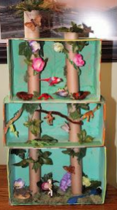 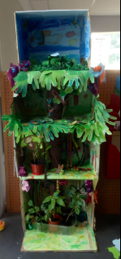 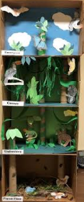

**Option 2: Draw, paint or create a picture of an animal that lives in the rainforest.**

Choose your canvas – paper, cardboard, cloth – your choice!

You could also find out additional facts about the animal – where it lives, what its diet is, which animal family is it related to, what characteristics is has…

