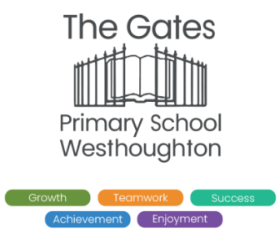

**Option 3: Create a Proud Flag showing that you are proud of yourself and your community.**

In Westhoughton, everyone is welcome and we celebrate the diversity of our town. Can you create a flag/poster/sign to welcome everyone? How will you make it clear that everyone is welcome here?

 

**LKS2 - Homework Web**

**Spring 2 – Forces**

Please choose 1 of the following projects to complete to help further your knowledge and understanding of this half term’s Science topic. **Alternatively, if you have a burning desire to complete a different related project, you can surprise your teacher with that instead.**

**Option 1:** **Save the egg!**

Create a parachute that will save your egg when dropped from a height.

You can use any material found in your home and an egg or toy with the aim of protecting it when it is dropped!

Record a video/send a photo/create a poster or even bring in your parachute to show the rest of class your ideas.

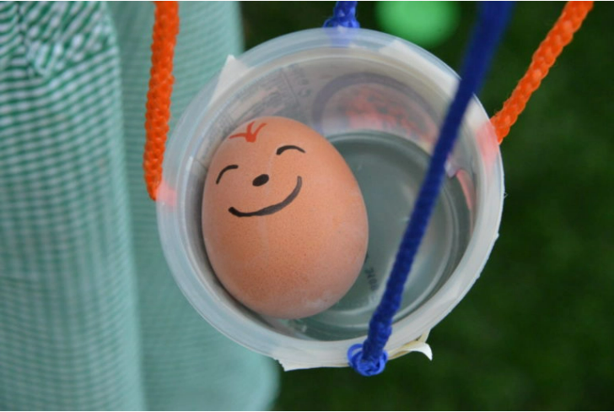

**Option 2: What might it be like with no gravity?**

Think about what it is like for an astronaut to have no gravity or air resistance when visiting the moon.

Let’s go to the moon!

Create a fact file/piece of art/diary entry/story about your journey to the moon.

Think about:

* What was the journey to the moon like?
* How did you prepare?
* How did the lack of gravity and air resistance feel?
* How long did you stay for?
* What was the mission?