

**Option 3: Plant Pictures**

Create a piece of artwork using your observation drawing skills. Choose a flower or plant and look carefully at the different parts to draw them accurately. You can use any media you wish

You could also follow a Draw With Rob to create your own version.

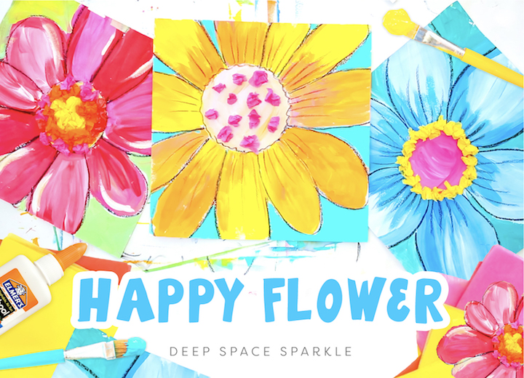

**LKS2 - Homework Web**

**Summer 1 – Plants**

Please choose 1 of the following projects to complete to help further your knowledge and understanding of this half term’s Science topic. **Alternatively, if you have a burning desire to complete a different related project, you can surprise your teacher with that instead.**

**Option 1:** **Physical Literacy**

Go for a walk around your local environment. What plants can you spot? Can you spot how plants disperse their seeds?

Use what you have found to create a poster showcasing the different plants you have found. Can you label the different parts?

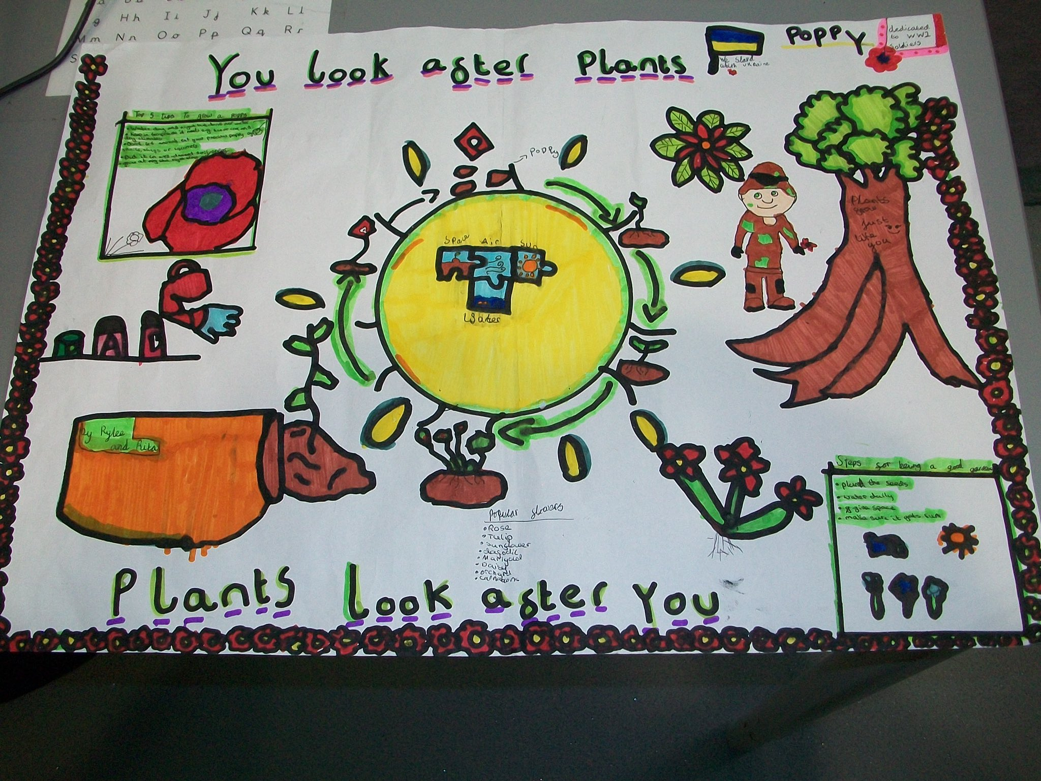

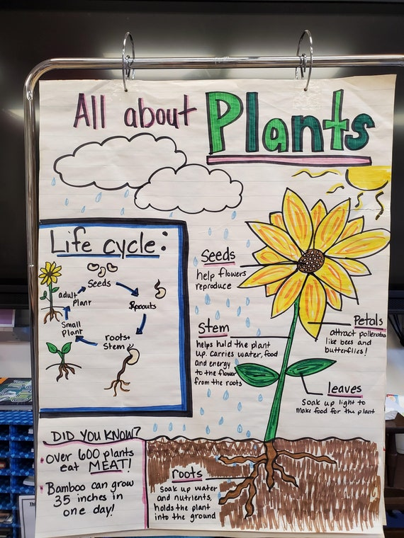

**Option 2: Parts of a plant**

Dissect the different parts of a plant looking closely at the reproductive parts. How do they make new seeds?

Create a model or a fact file to show what parts you have found? Can you tell me their different jobs too?

