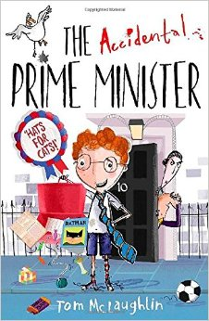**100 Books To Read In Year 3 And 4**

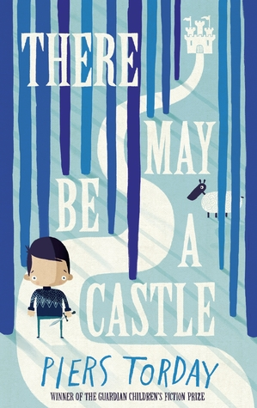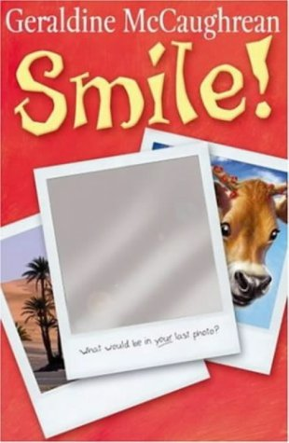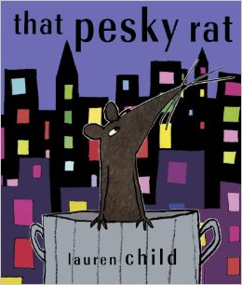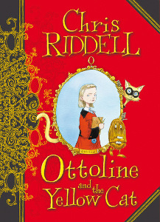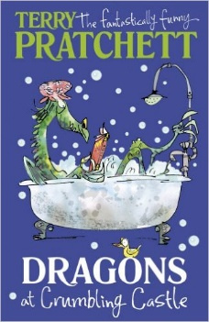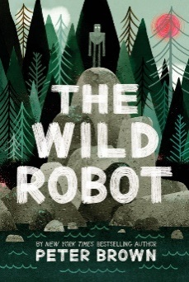

Shackleton’s Journey

William Grill

The Whisperer

Nick Butterworth

The Tale of Despereaux

Kate DiCamillo

Dragons at Crumbling Castle

Terry Pratchett

Fergus Crane

Paul Stewart and Chris Riddell

The Year of Billy Miller

Kevin Henkes

Liz Pichon

Frindle

Andrew Clements

The Shrimp

Emily Smith

The Invention of Huge Cabret

Brian Selznick

Mouse Noses on Toast

Darren Fletcher

There May Be A Castle

Piers Torday

That Pesky Rat

Lauren Child

Smile

Geraldine McCaughrean

Ottoline and the Yellow Cat

Chris Riddell

The Wild Robot

Peter Brown

The Accidental Prime Minister

Tom McLaughlin

