Swallows Class blog page
Title – Swallows Class Home Learning 15.04.20

Good morning Swallows!
I hope you had a wonderful Easter break and are now ready for some more online learning/ exercise / fun! Very quiet on the Pryle front Swallows, not much other than running around and tidying up after two whirlwinds! We’ve managed to clean cars, paint some fences and bake some cakes, we’ve never eaten as much!
We’ve managed to get out into the garden a lot, Eliza has enjoyed wreaking havoc (see the picture below!) I’ve managed to just about keep up with exercise, you’ll see a new man when we return, Clarke Kent in the making (I think not!)
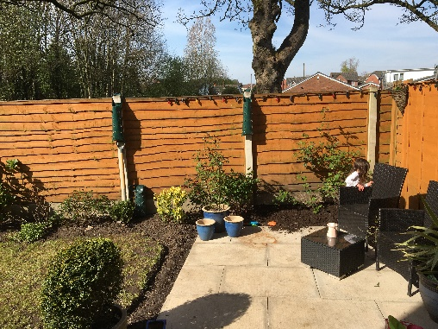
All that said, keep up the hard work, we are missing your smiling faces every day. Make sure to blog when you log-in to the school’s website (school spider), some have really made me smile. Let us know what you are up to Swallows! It has been great to see so many of you blogging, make the most of time with family and support each other. This is a great example from Aiden below!
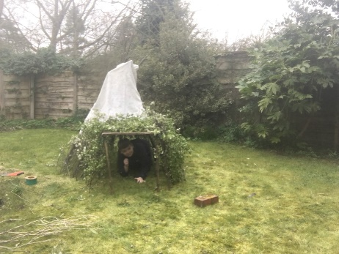
Hopefully this will end soon, when and we’ll be back in school with our friends laughing and playing. In the meantime, stay safe, keep smiling / PLANKING and make those ‘brews’ for your adults at home. (Be safe with the hot water! 🤪🤪)

Today’s home learning is:
LBQ:
Sign-in-code: upm (All lower-case)
There are 3 tasks set, Maths then 2x English (reading and grammar), please complete all by ‘exiting’ each using the little door tab.
IXL:
Maths – Year 3 – A.5, J.4, I.1
English – Year 3 – Grammar – L.1, P.4, P.7
Kick off the day with Newsround:
https://www.bbc.co.uk/newsround/news/watch_newsround

Don’t forget there are tasks on Purple Mash and Read Theory has some reading comprehensions available too.
You have all done a wonderful job on IXL so far – we’ve now answered over 14,000 questions as a class alone!!
Viyan Patel – 30 house points! (Answering over 2,200 questions alone!)
Jenson Barr, Lewis Vernon, Ava Mills and Harrison Gaskell – 10 house points all for practising yesterday even when there was no home learning set!
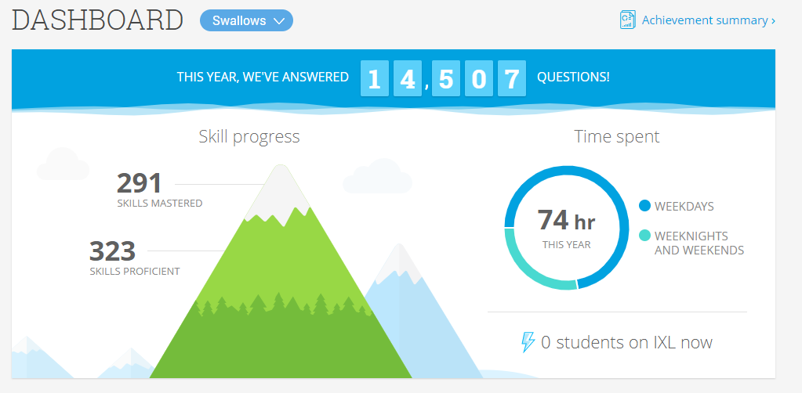
Have a wonderful day everyone! I’ll look forward to seeing all your hard work online and some blog updates.
Stay safe, Mr Pryle 🌈 🌈 🌈

