The Red Fox
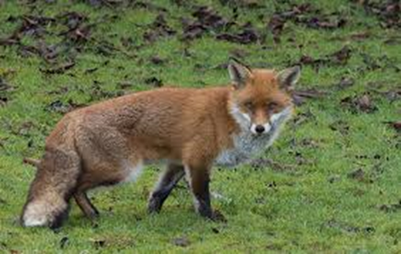
The red fox, also known as Vulpes vulpes, is the most widespread and numerous predators in Britain.
Foxes are mammals with a furry coat and pointed ears. They are easily recognised by their orange-brown fur and their bushy tail, which is sometimes called a brush. Foxes also have a long nose which helps them to search for food. Foxes have excellent hearing and a keen sense of smell.
Where do they live?
They can be found throughout the UK and can survive in most habitats – woods, farmlands, towns and cities. Normally a fox will sleep underground in a den, they can dig their own but they will often find a den made by another animal.
Daily Life
Foxes live as a family or a small community. There is a male (dog), a female (vixen), and their cubs. When the cubs are born, they can’t see, walk or hear, so their mother (vixen) stays in the den to look after them while the father (the dog) goes out to hunt for food for them all. The cubs stay in the den until they are old enough to go out and hunt. Although they live in a family group, they spend a lot of their time alone. As their eyes are specially adapted to night time vision, foxes are mostly active at night. Their hearing is also excellent which helps it to locate prey easily. Throughout the night a fox will roam its territory looking for food. Even though foxes forage on their own, members of the group meet up to play and groom each other. During the day foxes usually rest.
What do foxes eat?
Because they are omnivores, foxes can survive in many habitats. Although they prefer to eat meat, they also eat lots of other things: fruit, vegetables, worms. If the fox lives in a city, it will eat any food that is left out and it will go in people’s bins. If they find extra food then they will hide it and go back for it later when they are hungry again.
Did you know?
- Foxes have a short life only a few live longer than 3 years.
- Badgers and foxes have a strange relationship. Sometimes they compete for food, and they have been seen living together in badger setts.
- Fox poo is called scat.
- The foxes in Scotland are larger thank the ones in the rest of the UK.
- Large numbers are killed by cars, gamekeepers and farmers each year.
- Their tail has a few uses: helps them balance, keeps them warm in Winter and they use it to signal to other foxes.

