Fallow deer
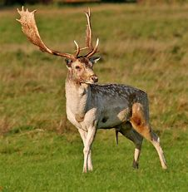
The fallow deer is a social, elegant species of deer that has a speckled layer of fur in the colours of brown and white and glorious pointed antlers. Introduced to Britain 1,000 years ago by the Normans, ever since it has lived in our woodlands.
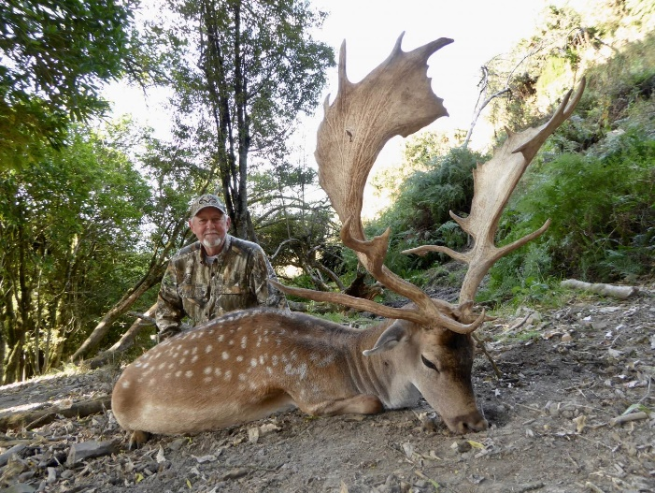
Where does it live?
The Fallow deer are spread across England, Wales, Southern Scotland and Ireland. They favour broadleaved woodland, grassland and parkland.
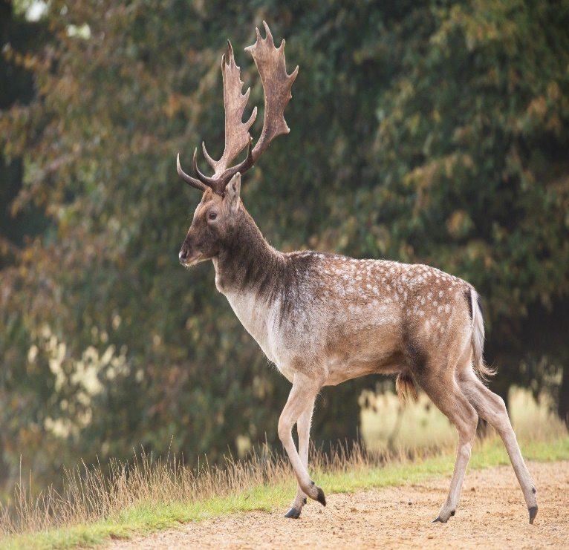
Quick Facts?
Common name: Fallow deer
Scientific name: Dama dama
Family: Cervidae
Habitat: Broadleaved woodland,
Grassland
Diet: grass, leaves, bark, nuts
And berries, fungi
Predators: no natural predators

