Welcome to Bolton
Introduction
Bolton – a fascinating, spectacular and bustling place to visit. The town is packed with so much greatness and history: Queen’s Park, Bolton Museum, Aquarium and Art Gallery, Rivington Pike and Smithills Hall. In this compact town, you are never too far away from a variety of attractions; making it a great place to visit.
History of Bolton
Bolton is a town in Greater Manchester in North West England. It has a population of 139,403. A former mill town, Bolton has been a production centre for textiles since Femlish Weavers settled in the area in the 14th century, introducing a wool and cotton – weaving tradition. A tradition of cotton spinning and weaving and improvements to spinning technology by local inventors, Richard Arkwright and Samuel Crompton, led to rapid growth of the textile industry in the 19th century. Its 216 cotton mills and 26 bleaching and dying works made it one of the largest and most productive centres of cotton spinning in the world.
Things to see and do
What are your interests? whether you are old or young, this exquisite place caters for everybody. It boasts an astonishing diversity of landscapes, moors, rivers and countless beauty spots. Shopping complexes are situated all around the town filled with shops, restaurants, cafes and some also include cinemas, play areas and bowling. If you like history then Bolton Museum, Hall ‘I’th’ Wood Museum, Bolton Steam Museum, Turton Tower, Fred Dibnah Heritage Centre and Smithills Hall are all worth a visit. Take a leisurely stroll around Rivington Pike, Moss Bank Park or Queen’s Park. Head over to the Octogan Theatre to watch a show.
Bolton is also the home of the football team Bolton Wanderers, who play home games at the University of Bolton Stadium.
So, what are you waiting for? Head over to Bolton, it has so much to offer!

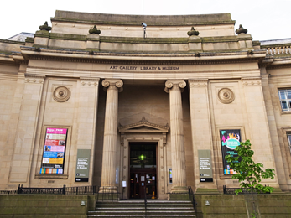
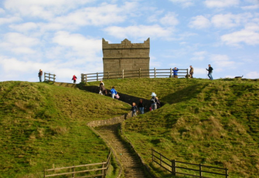
Bolton Museum Rivington
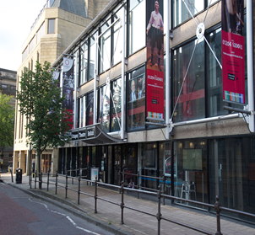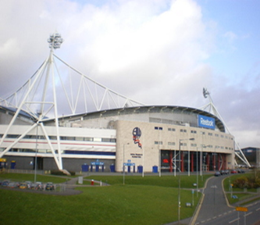
The Octagon Theatre Bolton Wanderers Stadium

