The following is an information leaflet on male running world records

Sprints

Usain bolt from Jamaica ran the 100 metres in 9.58 seconds and the 200 metres in 19.19 seconds and Wayde van Niekerk who is from South Africa ran the 400 metres in 43.03 seconds. Also, David Rudisha (Kenya) ran the 800 metres in 1 minute, 40.91 seconds.

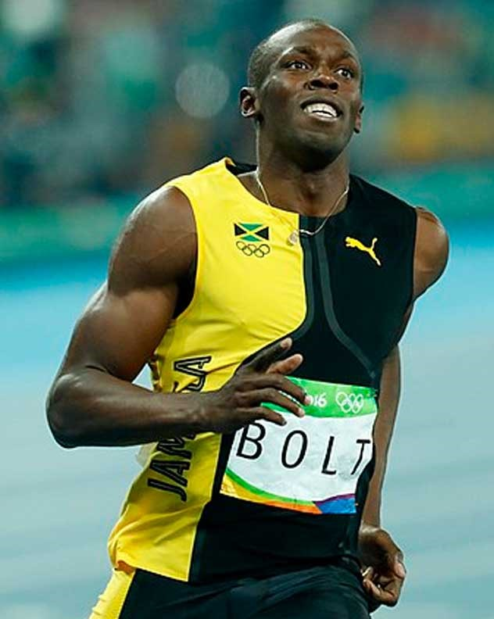

Alternative running

Saif Saaeed Shaheen who is from Qatar ran the 3000 metre steeplechase in 7 minutes, 53.63 seconds. Aries Merrittt ran the 110 metre hurdles in 12.80 seconds and Kevin Young ran the 400 metre hurdles in 46.78 seconds. These 2 people are from the United States of America.

Long distance

Noah Ngeny who is from Kenya ran the 1000 metres in 2 minutes and 11.96 seconds and Daniel Komen who is also from Kenya ran the 3000 metres in 7 minutes and 20.67 seconds. Kenenisa Bekele is from Ethiopia and he ran the 5000 metres in 12 minutes and 37.35 seconds and he ran the 10000 metres in 26 minutes and 17.53 seconds. Also, Hicham el Guerrouj who is from Morocco ran the 1500 metres in 3 minutes and 26 seconds, the 1600 metres in 3 minutes and 43.13 seconds and the 2000 metres in 4 minutes and 44.79 seconds.

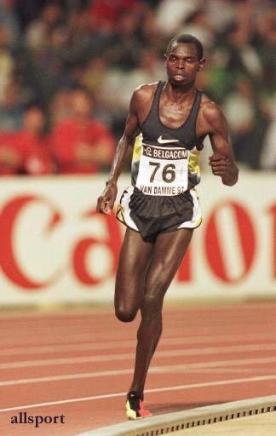

Ultra long distance

Haile Gebrselassie who is from Ethiopia ran the 20000 metres in 56 minutes and 26 seconds; he also ran 21285 metres in 1 hour. Geoffrey Kamworor ran a half marathon in 58 minutes and 1 second. The Kenyan, Moses Mosop ran the 25000 in 1 hour, 12 minutes and 25 seconds as well as running the 30000 metres in 1 hour, 26 minutes and 47 seconds. Eliud Kipchoge who is from Kenya ran a marathon in 2 hours, 1 minute and 39 seconds and Nao Kazami (Japan) ran 100000 metres in 6 hours, 9 minutes and 14 seconds.

