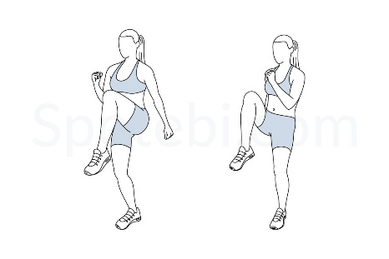 Aut1 Wk2

|  |  |  |
| --- | --- | --- |
| S | Jumping Jacks | Illustrated Exercise Guide | 5  Star Jumps |
| P | Bent Over Twist | Illustrated Exercise Guide | 5  Windmills |
| High Knees | Illustrated Exercise GuideO | High Knees | Illustrated Exercise GuideHigh Knees | Illustrated Exercise GuideHigh Knees | Illustrated Exercise Guide | 10  HHigh Knees | Illustrated Exercise Guideigh Knees |
| R | Run In Place | Illustrated Exercise Guide | 10 Second  Sprint on the spot |
| T | Squat | Illustrated Exercise Guide | 5  Squats |

