Activity 2:

Geography

Bring in some photographs of a time when you visited somewhere new in the UK.

Autumn 1

The United Kingdom

Here are some ideas that will support our topic learning this term. A minimum of one of these is to be completed.

Please send in any completed activities as and when for ‘Show and Tell’

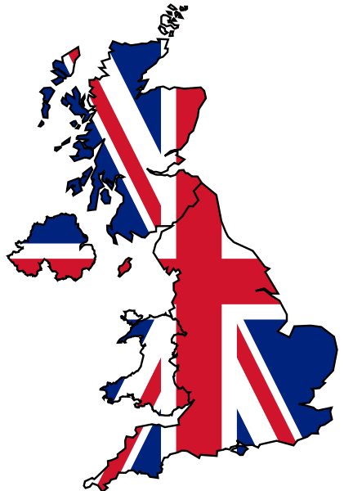

Activity 4:

Art

Create a collage of animals that you may find in your back garden.

How to help further

English: Write a story set in “The Jurassic Forest” Be as creative as you like!

Science: Investigate different food chains and present them in interesting ways.

Activity 3:

English

Create a fact file about any city in the United Kingdom.

Activity 6:

Computing

Draw a picture of your favourite place in the UK using purplemash.

Activity 5:

Maths

Make a set of top trump cards for animals that live in the UK.

Activity 1:

Science

Design your habitat. Be creative! This could be done using junk modelling, pictures or computer designs.